Ex.No: 8 Roll.No: 210701182

# PYTHON PROGRAM TO PERFORM OBJECT DETECTION WITH YOLOv3

Aim:

To perform object detection with YOLOv3 in python.

# Procedure:

1. Parse command-line arguments to choose between webcam, video, or image detection.
2. Load the pre-trained YOLO model, configuration file, and COCO class names.
3. Load and resize the input image or video frame.
4. Convert the input image/frame to a blob for YOLO processing.
5. Perform forward pass through the YOLO network to detect objects.
6. Extract bounding boxes, class IDs, and confidence scores from the YOLO output.
7. Apply non-maximum suppression to filter overlapping boxes.
8. Draw bounding boxes and labels on the detected objects in the image/frame.
9. Display the processed image/frame with detected objects.
10. Release video capture and close all OpenCV windows on exit.

# Code:

import cv2

import numpy as np import argparse import time

parser = argparse.ArgumentParser()

parser.add_argument('--webcam', help="True/False", default=False)

parser.add_argument('--play_video', help="Tue/False", default=False) parser.add_argument('--image', help="Tue/False", default=False) parser.add_argument('--video_path', help="Path of video file", default="videos/car_on_road.mp4")

parser.add_argument('--image_path', help="Path of image to detect objects", default="Images/bicycle.jpg")

parser.add_argument('--verbose', help="To print statements", default=True) args = parser.parse_args()

#Load yolo

def load_yolo():

net = cv2.dnn.readNet("yolov3.weights", "yolov3.cfg") classes = []

with open("coco.names", "r") as f:

classes = [line.strip() for line in f.readlines()]

output_layers = [layer_name for layer_name in net.getUnconnectedOutLayersNames()]

colors = np.random.uniform(0, 255, size=(len(classes), 3)) return net, classes, colors, output_layers

def load_image(img_path): # image loading

img = cv2.imread(img_path)

img = cv2.resize(img, None, fx=0.4, fy=0.4) height, width, channels = img.shape return img, height, width, channels

def start_webcam():

cap = cv2.VideoCapture(0)

return cap

def display_blob(blob): '''

Three images each for RED, GREEN, BLUE channel

'''

for b in blob:

for n, imgb in enumerate(b): cv2.imshow(str(n), imgb)

def detect_objects(img, net, outputLayers):

blob = cv2.dnn.blobFromImage(img, scalefactor=0.00392, size=(320, 320), mean=(0, 0, 0), swapRB=True, crop=False)

net.setInput(blob)

outputs = net.forward(outputLayers) return blob, outputs

def get_box_dimensions(outputs, height, width): boxes = []

confs = [] class_ids = []

for output in outputs: for detect in output:

scores = detect[5:]

class_id = np.argmax(scores) conf = scores[class_id]

if conf > 0.3:

center_x = int(detect[0] * width) center_y = int(detect[1] * height) w = int(detect[2] * width)

h = int(detect[3] * height)

x = int(center_x - w/2) y = int(center_y - h / 2)

boxes.append([x, y, w, h]) confs.append(float(conf)) class_ids.append(class_id)

return boxes, confs, class_ids

def draw_labels(boxes, confs, colors, class_ids, classes, img): indexes = cv2.dnn.NMSBoxes(boxes, confs, 0.5, 0.4)

font = cv2.FONT_HERSHEY_PLAIN

for i in range(len(boxes)): if i in indexes:

x, y, w, h = boxes[i]

label = str(classes[class_ids[i]]) color = colors[i]

cv2.rectangle(img, (x,y), (x+w, y+h), color, 2) cv2.putText(img, label, (x, y - 5), font, 1, color, 1)

cv2.imshow("Image", img)

def image_detect(img_path):

model, classes, colors, output_layers = load_yolo() image, height, width, channels = load_image(img_path)

blob, outputs = detect_objects(image, model, output_layers)

boxes, confs, class_ids = get_box_dimensions(outputs, height, width) draw_labels(boxes, confs, colors, class_ids, classes, image)

while True:

key = cv2.waitKey(1) if key == 27:

break

def webcam_detect():

model, classes, colors, output_layers = load_yolo() cap = start_webcam()

while True:

_, frame = cap.read()

height, width, channels = frame.shape

blob, outputs = detect_objects(frame, model, output_layers)

boxes, confs, class_ids = get_box_dimensions(outputs, height, width) draw_labels(boxes, confs, colors, class_ids, classes, frame)

key = cv2.waitKey(1) if key == 27:

break cap.release()

def start_video(video_path):

model, classes, colors, output_layers = load_yolo() cap = cv2.VideoCapture(video_path)

while True:

_, frame = cap.read()

height, width, channels = frame.shape

blob, outputs = detect_objects(frame, model, output_layers)

boxes, confs, class_ids = get_box_dimensions(outputs, height, width) draw_labels(boxes, confs, colors, class_ids, classes, frame)

key = cv2.waitKey(1) if key == 27:

break cap.release()

if name == ' main ': webcam = args.webcam video_play = args.play_video

image = args.image if webcam:

if args.verbose:

print('---- Starting Web Cam object detection ')

webcam_detect() if video_play:

video_path = args.video_path if args.verbose:

print('Opening '+video_path+" ")

start_video(video_path) if image:

image_path = args.image_path if args.verbose:

print("Opening "+image_path+" ")

image_detect(image_path) cv2.destroyAllWindows()

# Output:

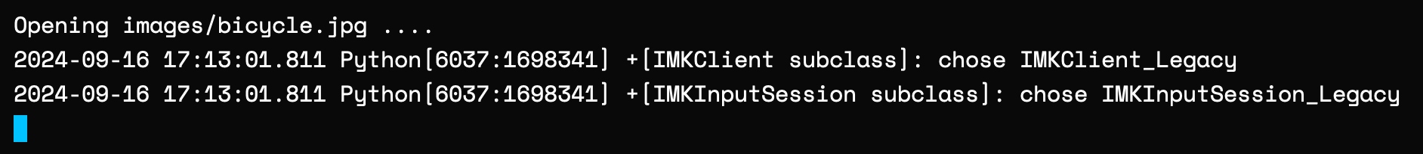

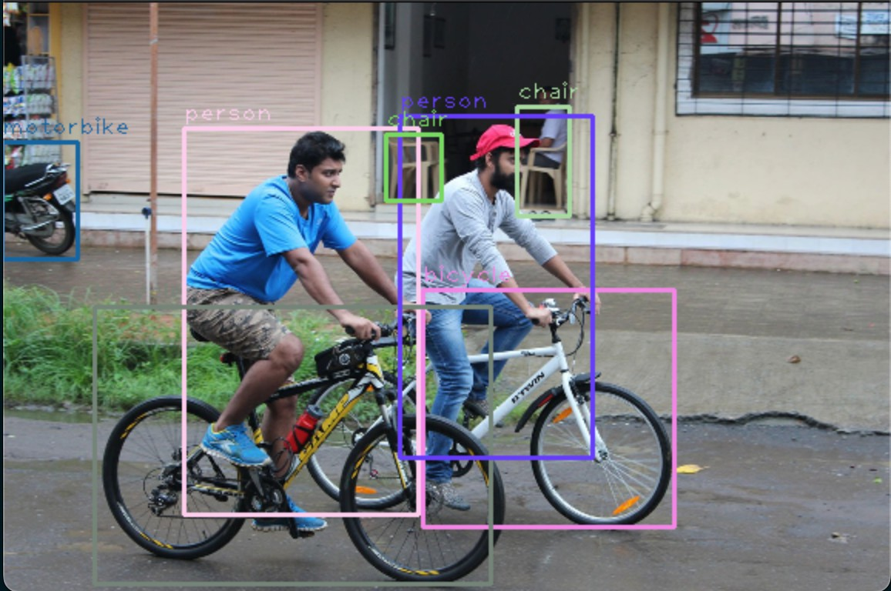

Result:

Thus, to perform object detection using YOLOv3 in python has been completed successfully.